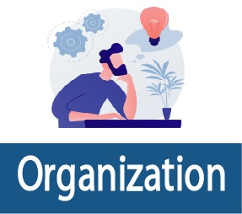
 CEO/Owner of the company’s thoughts, it is difficult to track the business activities, and they are looking for a smart and strong ERP system. decided to go for cloud ERP. Search a popular ERP team and discussed with the ERP team to implement their ERP. To obtain a clear view, the CEO meets with the ERP team, and the ERP team then demonstrates their ERP. Finally, the CEO found a clear demonstration for all their requirements and finally decided to implement the ERP.
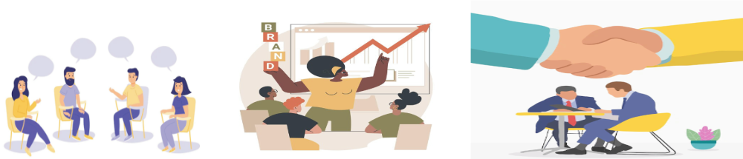
Goal: to gather and document business requirements
This step includes collection of requirements for software product development from stakeholders, industry experts, and even potential customers. After that, the project owners outline the project scope, defining a budget, resources, deadlines, and potential risks and quality assurance requirements. All requirements are encapsulated in a formal document, Software Requirement Specification. Project managers, business analysts, and software developers will refer to this document frequently.
Outcome: Setting requirements and writing SRS

Goal: To convert requirements into detailed software architecture.
The Design phase models the way a software application will work. Some aspects of the design include:
- Architecture – Specifies programming language, industry practices, overall design, and use of any templates or boilerplate
- User Interface – Defines the ways customers interact with the software, and how the software responds to input
- Platforms – Defines the platforms on which the software will run, such as Apple, Android, Windows version, Linux, or even gaming consoles
- Programming – Not just the programming language, but including methods of solving problems and performing tasks in the application
- Communications – Defines the methods that the application can communicate with other assets, such as a central server or other instances of the application
- Security – Defines the measures taken to secure the application, and may include SSL traffic encryption, password protection, and secure storage of user credentials
Outcome: Software design description.

Goal: Translate the design of the system into code.
This is a lengthy phase though less complicated than the previous two. Using the design description, programmers code the modules using the chosen programming language. The coding tasks are divided between the software engineering team members according to their skillset. Front-end developers create codes for displaying an application or product UI and the elements users need to interplay with the site. Their Back-end counterparts are in charge of the technical side of a product.
Establish conditions for organized and consistent coding:
- Use proper guidelines;
- Supervise every developer;
- Automate deployment process;
- Nourish the best programming practices.
Well-written code significantly reduces the number of test runs and maintenance-related problems at the next stages.
Outcome: testable, functional software, and a Source Code Document.

Goal: Code verification and bugs detection.
This stage usually goes hand in hand with development. Testing provides quality assurance and makes sure that the project is implemented according to the requirements. During testing, if any number of bugs are found, the team returns to development again. It’s common that a short cycle of these two steps will repeat until all bugs are removed.
Outcome: Software is completely free of bugs and compliant.





